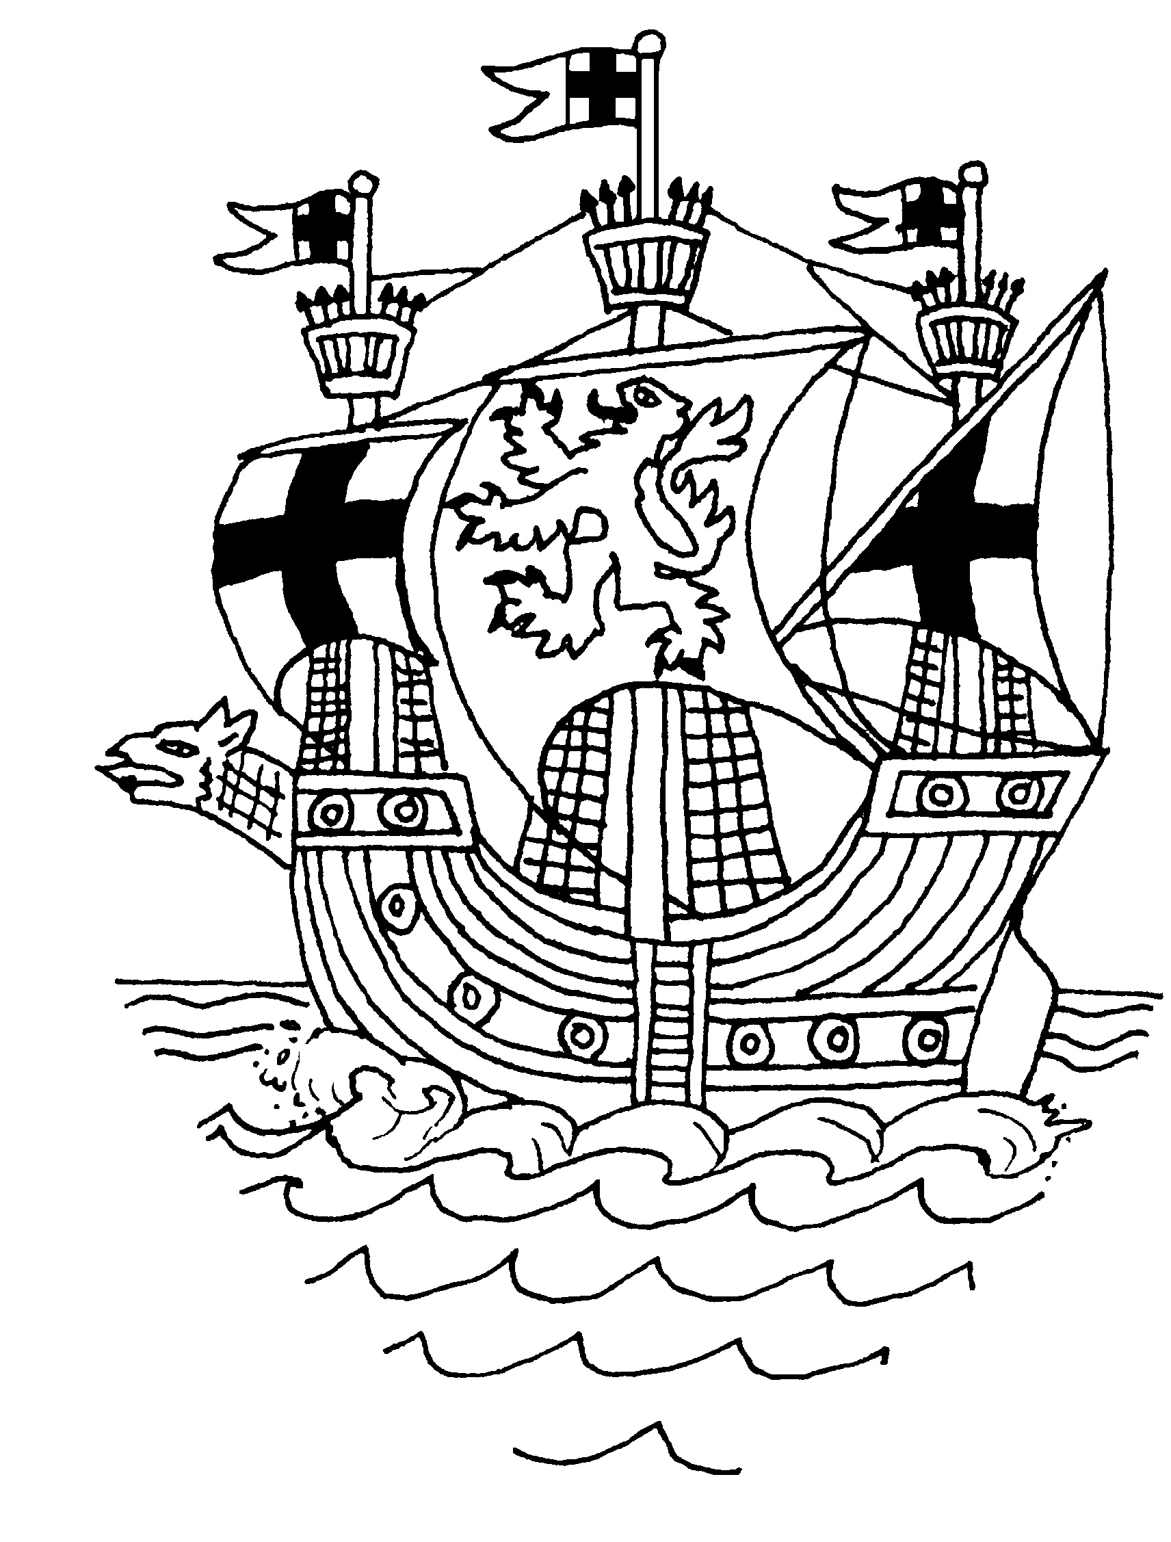

ALDEBURGH TOWN COUNCIL
THE MOOT HALL, MARKET CROSS PLACE
ALDEBURGH, SUFFOLK, IP15 5DS
Tel: 01728 452158 Email: aldeburghtc@moothall1.fsnet.co.uk

NOTICE OF THE ALDEBURGH ANNUAL TOWN MEETING
To be held on
Thursday 8 March 2018 7pm
At Aldeburgh Community Centre

PRESS & MEMBERS OF THE PUBLIC WELCOME

AGENDA

- 1. Apologies for absence
- 2. Minutes of the Annual Town meeting held on Thursday 9 March 2017.
3. Mayor’s Community Award
4. Mayor’s Report

5. Other Reports

- County Councillor
- Aldeburgh Community & Sports Centre
- The Police
- Aldeburgh Fire & Rescue Service
- Aldeburgh Coastguards
- Aldeburgh Museum Trust
- Aldeburgh Society
- League of Friends of the Hospital
- Aldeburgh and District Local History Society

Reports have been received from the following organisations:
      - Aldeburgh Primary School
      - District Councillors
      - Aldeburgh Business Association
      - Aldeburgh United Charities
      - Aldeburgh Carnival

